**Project Report**

This project involves analysing **Amazon sales data** to gain insights into sales performance identify trends, and make data-driven business decisions**.**

**Objective:** Analyse Amazon sales data to understand sales trends, identify top-performing products, and optimize inventory and marketing strategies.

**We will use the following Libraries:**

**1.) Pandas:** Data manipulation and analysis.

**2.) Numpy:** Numerical operation and calculations**.**

**3.) Matplotlib:** Data visualisation and plotting.

**4.) Seaborn:** Enhanced data visualisation and statistical graphics.

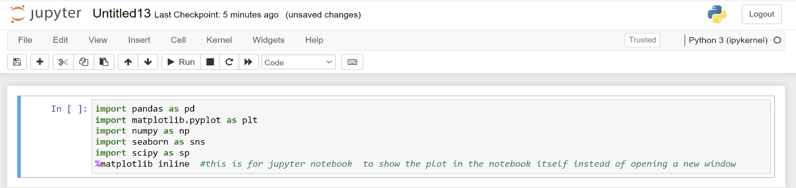**5.) Scipy:** Scientific computing and advanced mathematical operations.

**Data Loading:**

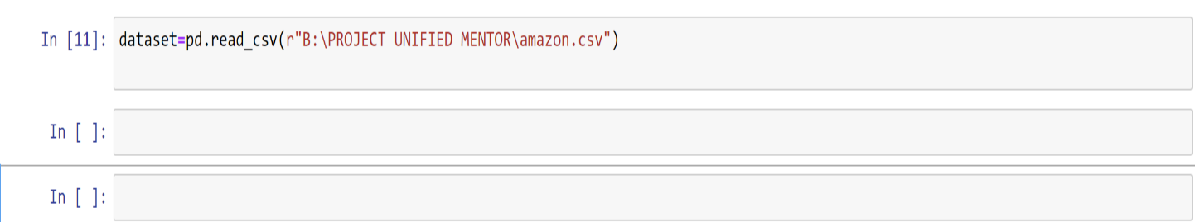

**Data Exploration:**

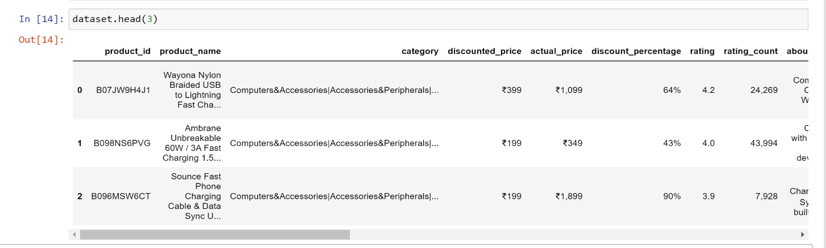**Let’s have a look on top 3 rows of the dataset**

**Let’s have a look on bottom 3 rows of the dataset**

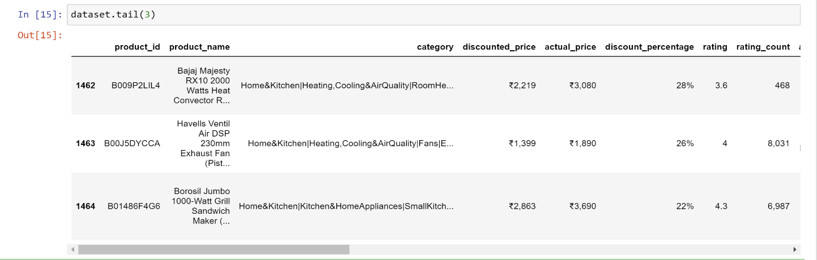

**Let’s see the maximum columns of the dataset**

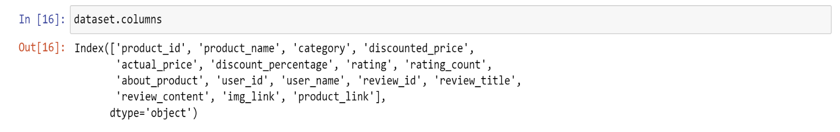

**Let’s have look on shape of the dataset**

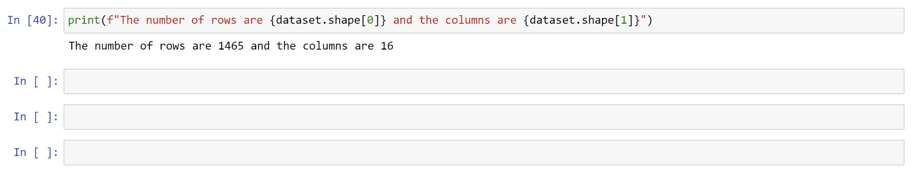

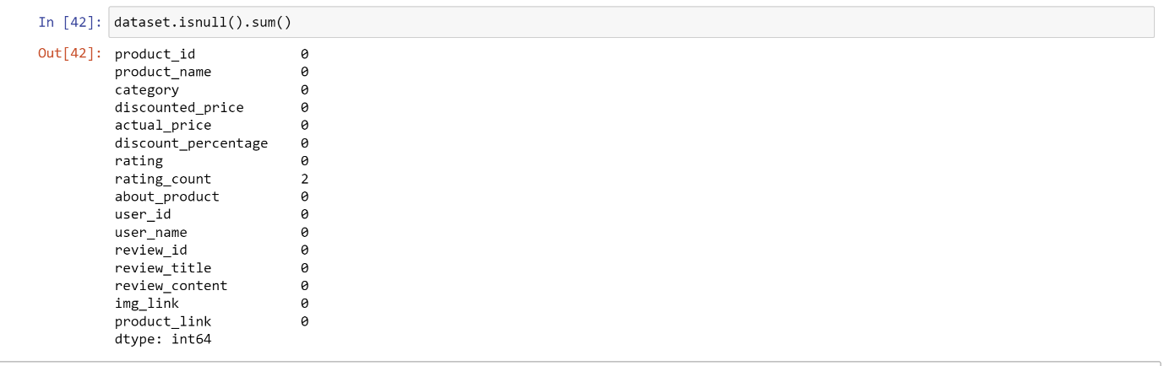**Let’s see the sum of the null values present in the dataset**

**We fill the null values by forward filling method**

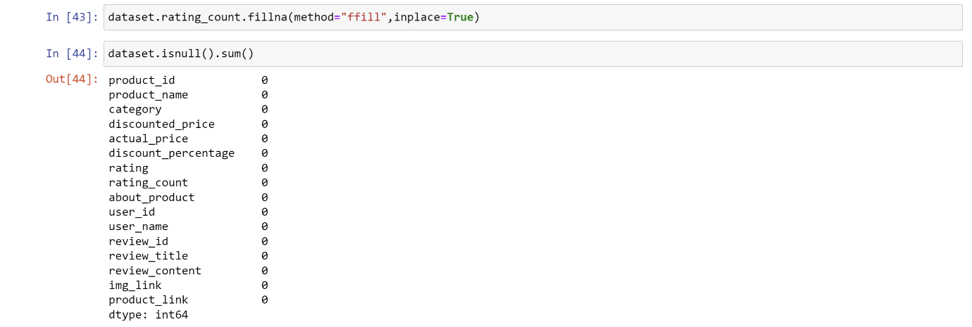

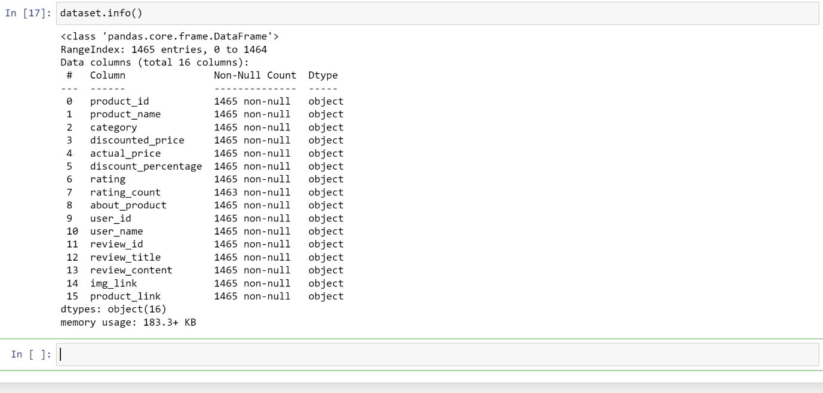**Let’s see the information of the dataset like datatypes of each column using info function**

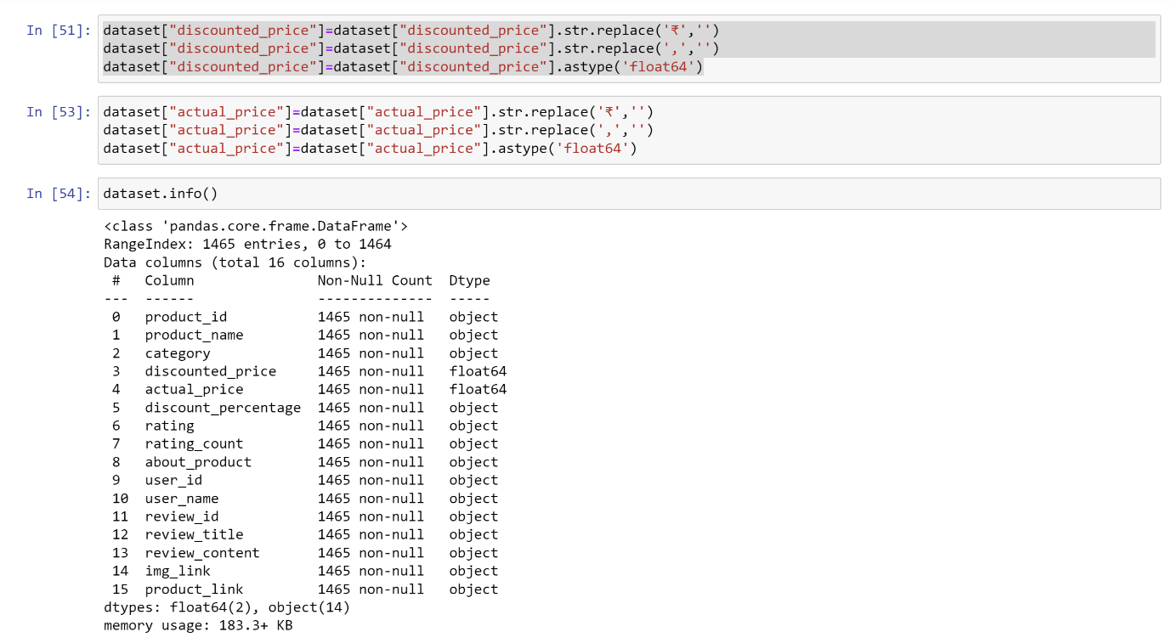**Changing the data types of columns into float**

**Observation:**

1.) There are **1465 rows** and **16 columns**.

2.) The columns in the dataset are:

'product_id', 'product_name', 'category', 'discounted_price' 'actual_price', 'discount_percentage', 'rating', 'rating_count', 'about_product’, ‘user_id', 'user_name', 'review_id', 'review_title', 'review_content', 'img_link', 'product_link'

3.) There are few missing values the dataset which we filled by forward filling method.

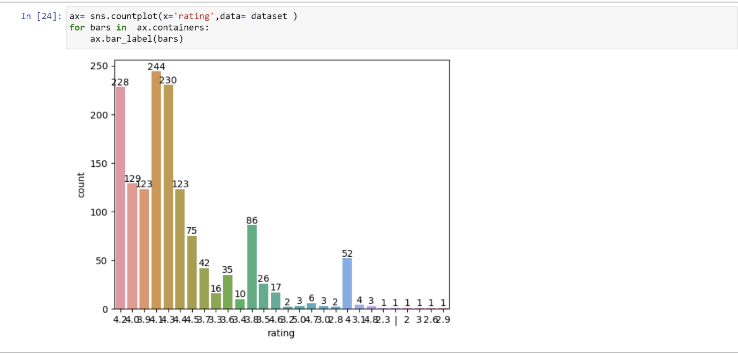**EXPLORATORY DATA ANALYSIS**

**Count plot of rating:**

**NAME: ABHISHEK SAINI**

**EMAIL: sainiabhi983@gmail.com**